Name ______________________ Document Analysis Notes

Period _____ Date ____________ Forensics

1. Document Analysis is a very broad area in the field of forensics.
   1. Definition: it is the examination and comparison of questioned documents with known material.
   2. Experts establish the authenticity of the documents and detects any changes, erasures or obliterations that may have occurred.
2. Questioned Document
   1. Definition: any signature, handwriting, typewriting, printed or other written mark whose source or authenticity is in dispute or uncertain.
      1. Examples: Checks, certificates, wills, passports, licenses, money, letters, contracts, suicide notes, receipts, lottery tickets…
3. Document Expert
   1. Definition: a specially trained person who scientifically analyzes handwriting and other features in a document.
   2. Graphology is the science using handwriting to study personality. It may be used in CSI detective work.
4. History of Handwriting Analysis:
   1. Every person’s handwriting is unique and personalized.
   2. An Exemplar is a known sample of handwriting to refer to.
      1. Items that could be used as exemplars: letters, greeting cards, calendars, notes…)
   3. 1930’s handwriting samples helped convict Bruno Richard Hauptman of the kidnapping and murder of Charles Lindberg’s son.
   4. 1999 U.S. Court of Appeals ruled that handwriting analysis was admissible in court.

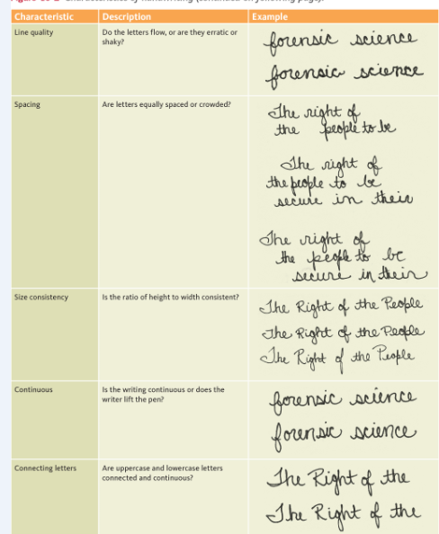

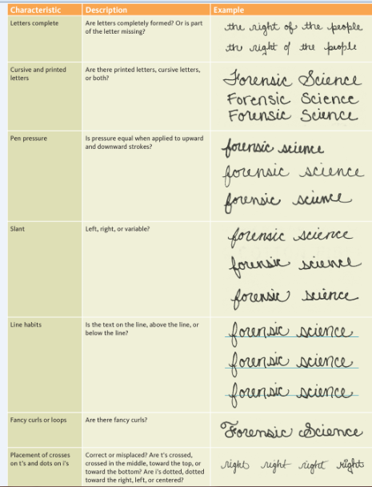

1. Graphology – the study of handwriting and the inferring of character or aptitude.
   1. Handwriting is a projection of personality
   2. Why people would like to know about graphology
      1. Self knowledge
      2. Couple’s counseling before marriage
      3. Understanding ancestor
      4. Therapists can judge progress
      5. Companies may analyze handwriting to determine if the job candidate is suitable for the position
      6. Law enforcement in profiling and witness credibility.
   3. What can influence handwriting:
      1. Mood, illness, drugs, amount of sleep, comfort of writer, type of writing, instrument, age, how they were taught to write in school.
   4. What can be determined by looking at handwriting:
      1. Social style: introvert/extrovert
      2. Thinking style: logical/intuitive
      3. Ego strength: strong/weak
      4. Use of energy: careful/wild
      5. Fear and inhibitions: learning from past experiences
      6. Locus of control: self-discipline, painful experiences, childhood conditioning
   5. What can’t be determined by looking at handwriting:
      1. Gender
      2. Race
      3. Age
      4. Sexual preference
      5. Which hand the writer writes with
      6. Religion
   6. Exemplars:
      1. Full page of original writing on unlined paper.
      2. Subject should be the writer’s choice
      3. If the write would rather print, ask for a sample of both
      4. Writer chooses a pen that’s comfortable
      5. The Writer can use pencil it that’s the only choice.
      6. The exemplar must be written on a smooth surface
   7. 75 – 80% of Handwriting analysis is fairly correct.
   8. * The complete Idiot’s guide to Handwriting Analysis – Sheila Lowe
   9. Technology and Handwriting analysis:
      1. Infrared Stereoscope – can determine if more than one kind of ink was used one a document
      2. Biometric Signature Pads – (signing the computer pad with a stylus) – can recognize your signature, speed, pressure and rhythm of signing
      3. Computerized Analysis
         1. Forensic Information System for Handwriting (FISH) is used by the secret service.
         2. Scan in the exemplar and the computer can search for handwriting matches.
2. Forgery – to make, alter or falsify a person’s signature or another aspect of a document with intent to deceive
   1. Examples: checks, employment records, legal agreements, licenses and wills
3. Fraudulence – when material gain accompanies a forgery.
4. Preventing Check Forgery:
   1. Print checks on chemically sensitive paper
   2. Use a large font size because it requires more ink and is more difficult to alter
   3. Use high-resolution borders on the checks that are difficult to copy
   4. Print checks with multiple color patterns
   5. Embed fibers in checks that glow under different types of lights
   6. Use chemical-wash detection systems that change color when a check is altered.
5. Literary Forgery is the forgery of a piece of writing, such as a historic letter or manuscript Ex. A letter written by Charles Darwin
6. Counterfeiting
   1. Definition – when false documents or other items are copied for the purpose of deception.
   2. Most commonly counterfeited: traveler’s checks, certain bonds and currency
   3. Counterfeiting money is one of the oldest crimes
   4. It is considered a federal felony and punishable with up to 15 years in prison.
7. Counterfeit Currency
   1. The secret service has updated currency to make it less possible to scan.
   2. Money is printed on special paper to make reproduction more difficult.
   3. Bills were redesigned
      1. $20 in October 2003
      2. $50 in Sept 2004
      3. $10 in March 2006
      4. $5 in Feb 2008
   4. Detecting counterfeit currency
      1. Use the counterfeit-detecting pens that contain iodine
      2. Counterfeit bills will turn bluish-black. Iodine has a chemical reaction to normal copy paper.
      3. Real bills will have a yellow line that will fade.
      4. 98% effective
   5. Features found in real currency
      1. Portrait stands out from background
      2. Microprinting around security threads and around the portrait
      3. Serial number is evenly spaced and the same color as the treasury seal.
      4. Federal Seal has no sharp points but treasury seal has sharp, clear saw tooth points.
      5. Clear red and blue fibers are woven throughout the bill
      6. A watermark appears on the right side of the portrait in the light
      7. When tilted, the number in the lower right-hand corner shifts color.

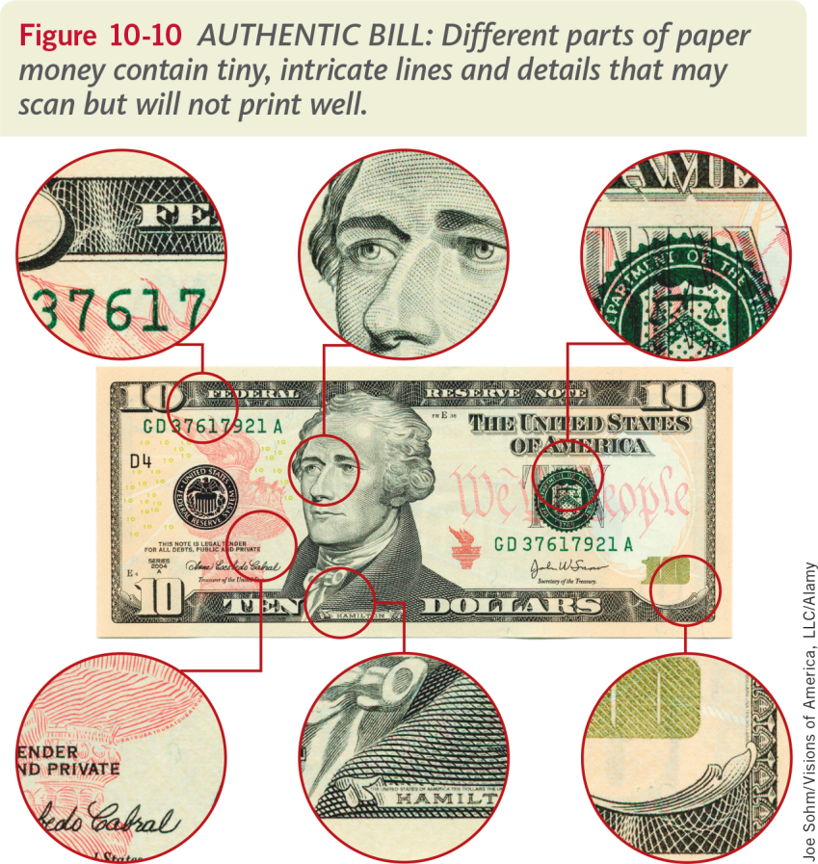

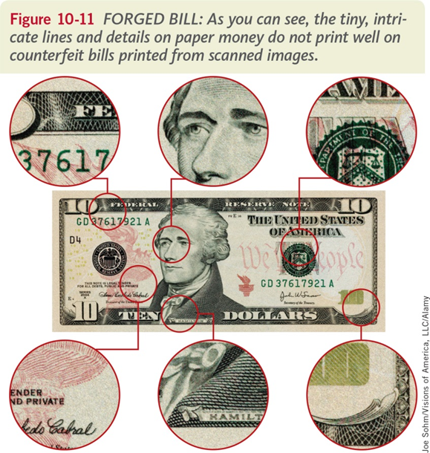

1. Chromatography
   1. Definition: the physical separation of a mixture into its individual components
   2. CSI analysts use chromatography to separate the components of inks and dyes such as those found in pens, markers, clothing, and candy shells.
   3. Chromatography can also be used to separate the colored pigments in plants or used to determine the chemical composition of many substances
   4. Examples of Chromatography
      * 1. Liquid Chromatography is used to identify unknown plant pigments and other compounds.
        2. Thin-Layer Chromatography use thin plastic/glass trays to identify the composition of pigments.
        3. Gas Chromatography is used to identify unknown samples of gas
        4. Paper Chromatography is used to separate inks, dyes, plant pigments and make-up.
   5. Mixture - 2 or more substances that are mixed together but not chemically combined.
      1. Examples:
         1. Air, N2, O2, CO2
         2. Bowl of Cereal: cereal and milk
         3. Soda Pop: CO2 and corn syrup and water
         4. Fog: Water in air
   6. Compounds are two or more elements that are chemically combined
      1. Examples:
         1. Salt: Sodium and Chorine
         2. Water: H2O
   7. Solutions are mixtures in which one substance is dissolved into another substance
      1. Solute: the substance that is dissolved
      2. Solvent: the substance that does the dissolving
      3. Identify the solute and solvent in the table below

|  |  |  |
| --- | --- | --- |
| Solution | Solute | Solvent |
| Lemonade | Sugar and lemon juice | Water |
| Soda Pop | Sugar and syrup | Water |
| Ocean Water | Salts | Water |